# Monte Carlo Simulations of Stock Prices

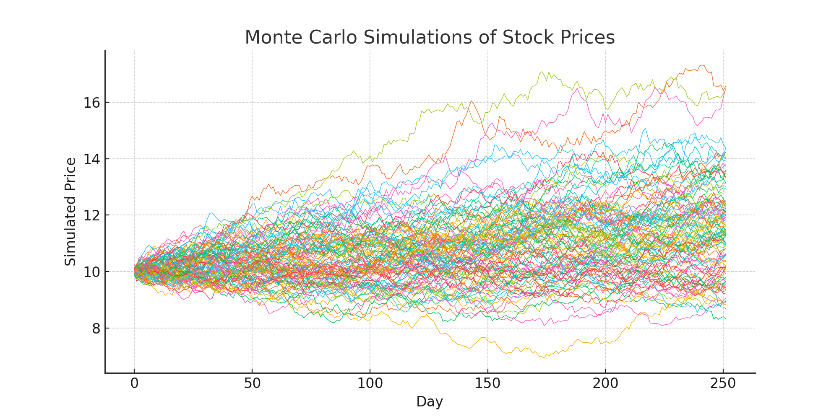

## Python Code

for i in range(100):  
 rand_rets = np.random.normal(mu, vol, T) + 1  
 forecasted_values = S0 * rand_rets.cumprod()  
 plt.plot(range(T), forecasted_values)  
plt.show()

## Explanation

This code simulates 100 possible price paths for a stock using Monte Carlo simulation. Each path represents 252 trading days and is generated using random daily returns based on average return (mu) and volatility (vol). These simulations help understand potential future price scenarios without relying on historical data.